1. Intro to Data Storytelling
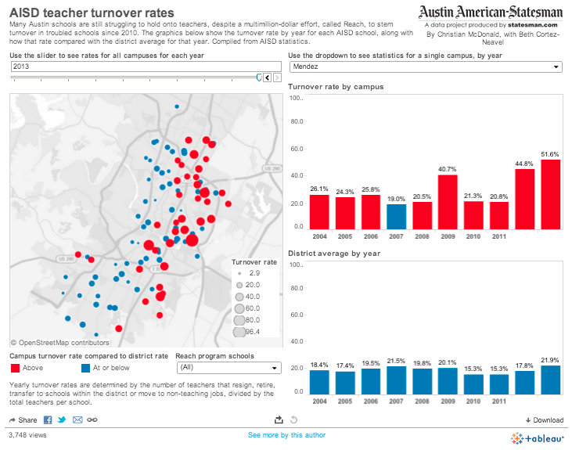
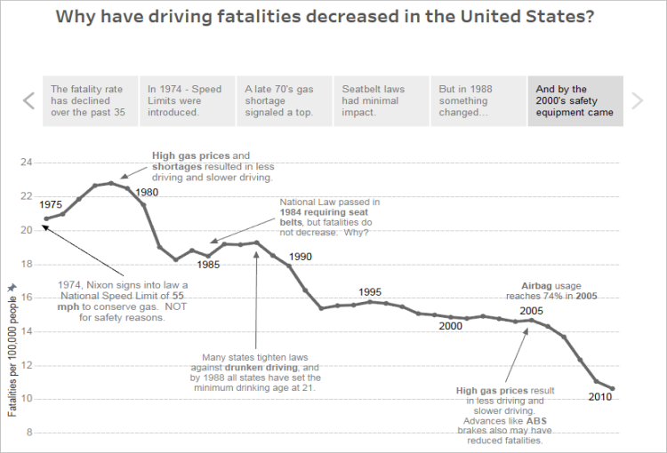
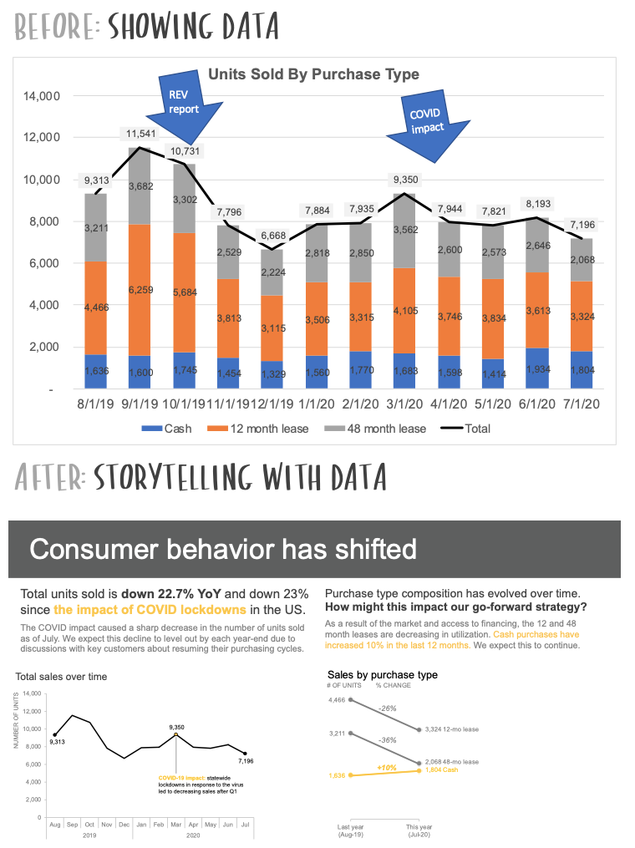
4
Data storytelling is the process of turning data into insights that people can understand and relate to. Instead of showing charts only, you help the viewer answer clear questions like:
- What is happening?
- Why is it happening?
- What should we do next?
A good story contains three parts:
- Setup
Context. What problem or question you want to explore.
- Insight
Visuals and patterns that explain what is happening.
- Conclusion or call to action
What the user should do or think after seeing the data.

2. Creating a Data Story in Tableau
A. Build the visuals
Before storytelling, prepare a set of focused sheets:
- Sales over time (line chart)
- Sales breakdown by Category (bar chart)
- Profit distribution (scatter or heat map)
- Top performing or worst performing Products (table or bar)
B. Design the Story layout in Tableau
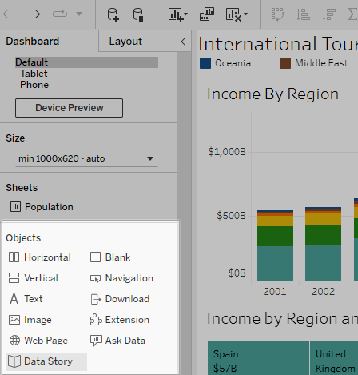
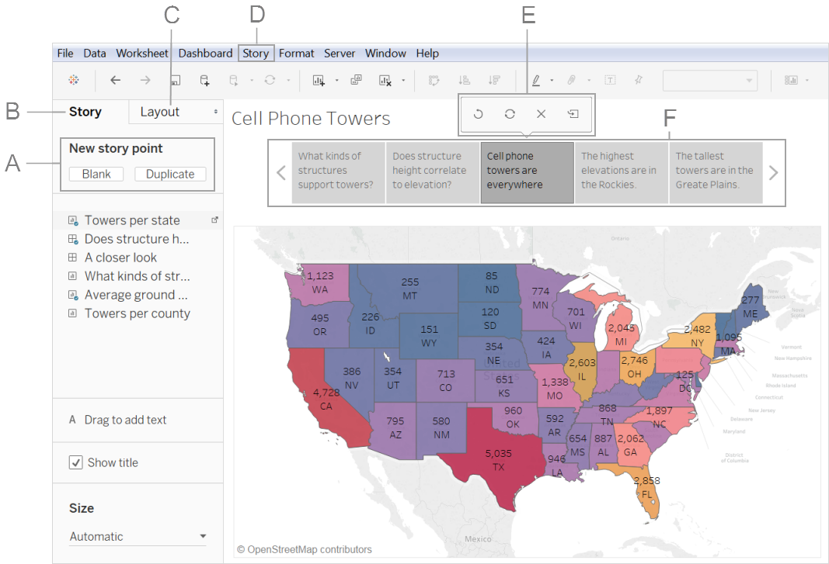
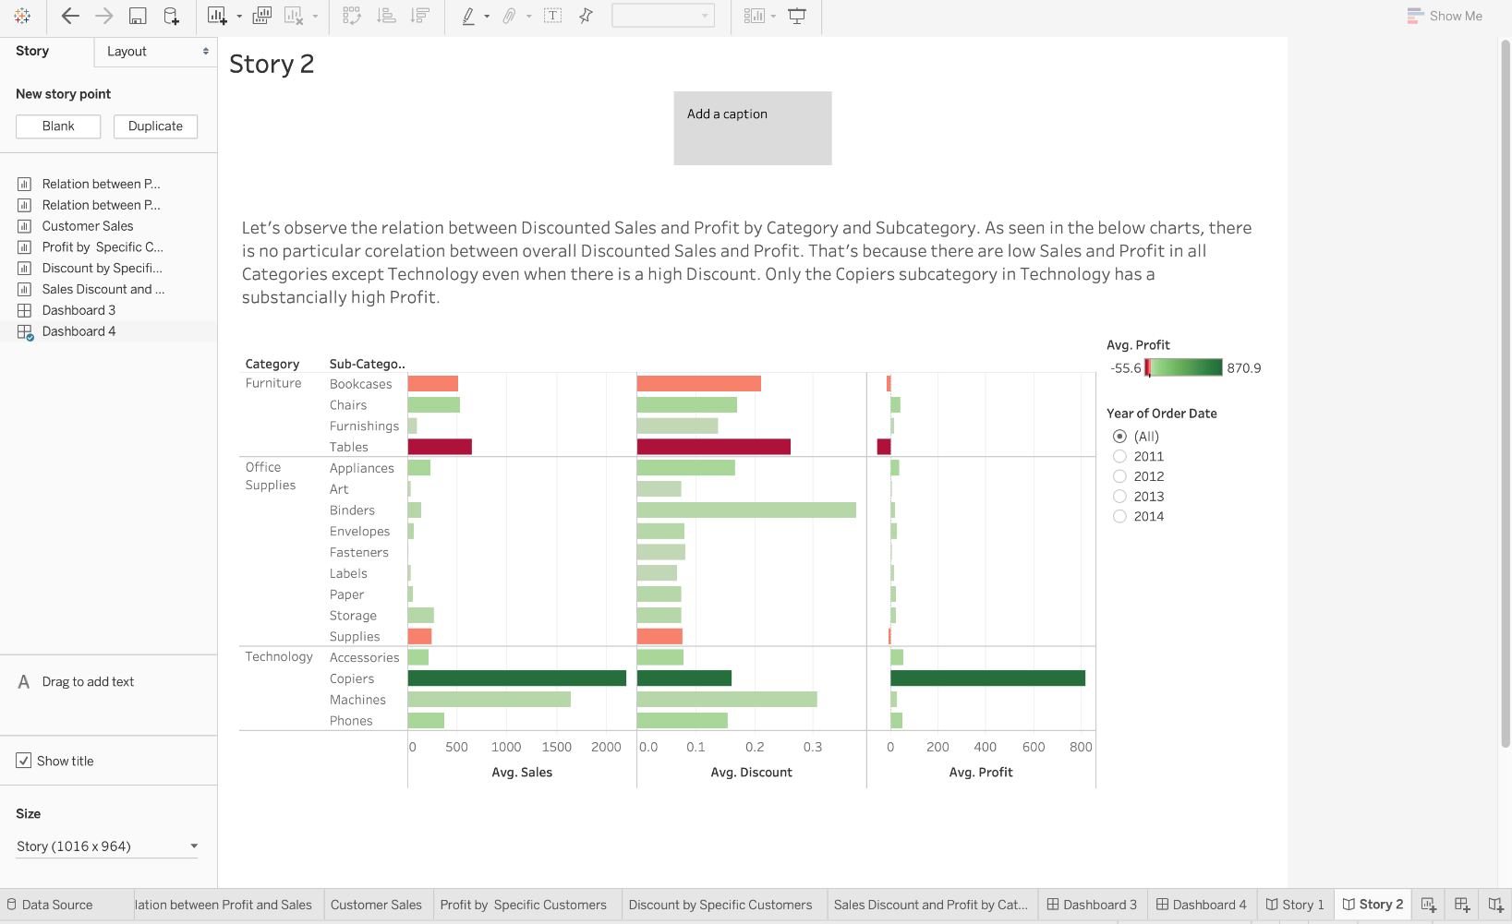
4
Steps
- At the bottom, click New Story.
- You will see a blank canvas with Story Points on the left.
- Drag dashboards or worksheets into the canvas to create each “chapter”.
- Add a caption above each story page to explain what the viewer should notice.
- Use Story Points to show your narrative step by step:
  - Point 1: Overview
  - Point 2: Breakdown by Category
  - Point 3: Profit analysis
  - Point 4: Recommendation
Tips
- Don’t overload a single story page.
- Use simple headlines like “East Region drives most revenue” rather than generic labels.

3. Overview of the Tableau Ecosystem
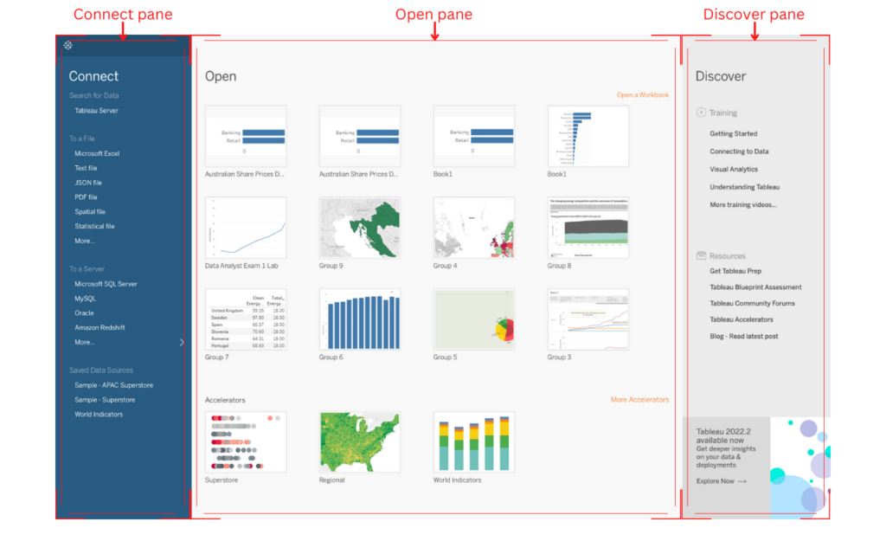

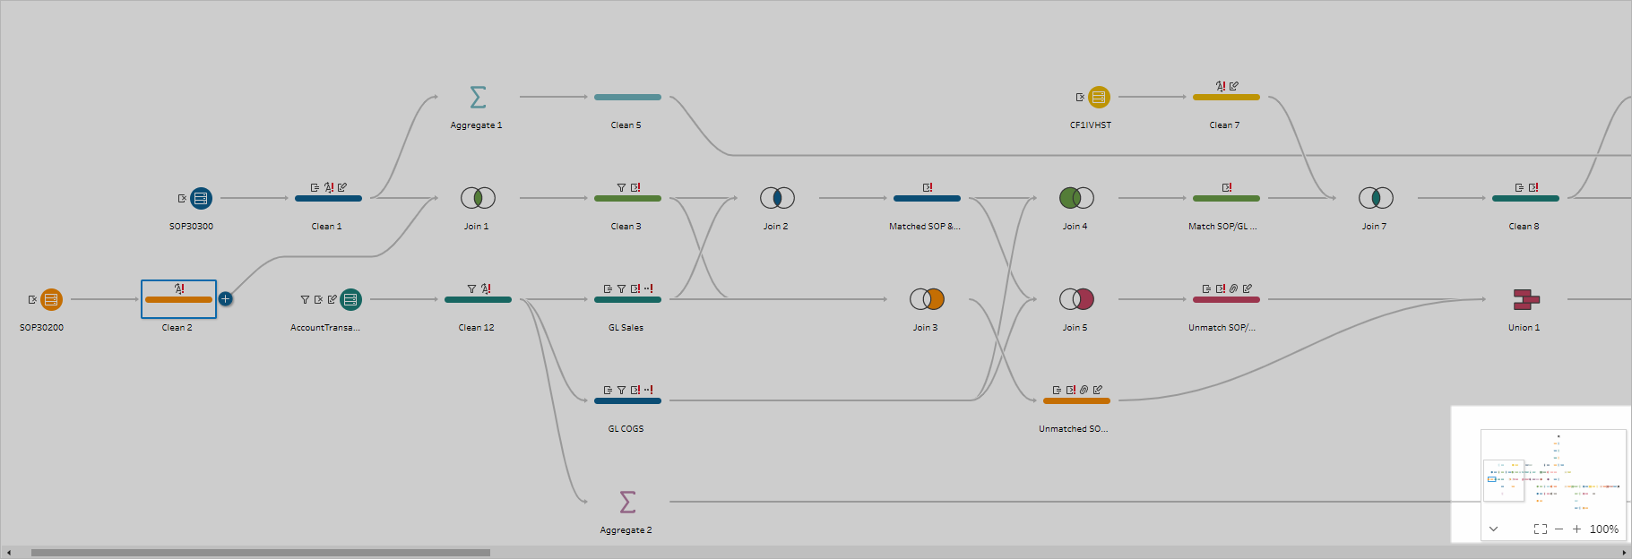
4
The Tableau ecosystem consists of several tools that cover end-to-end analysis:
Tableau Desktop
- Core data analytics and visualization tool.
- Used to prepare dashboards, stories, and visuals.
Tableau Prep
- Used for cleaning, shaping, and combining data before analysis.
- Good for joins, unions, and cleaning large datasets.
Tableau Server / Tableau Cloud
- Publishing dashboards for teams or organizations.
- Provides access control, collaboration, scheduled refresh, and sharing.
Tableau Public
- Free platform to publish dashboards publicly.
- Good for students, portfolios, or community learning.

4. Further Learning Opportunities
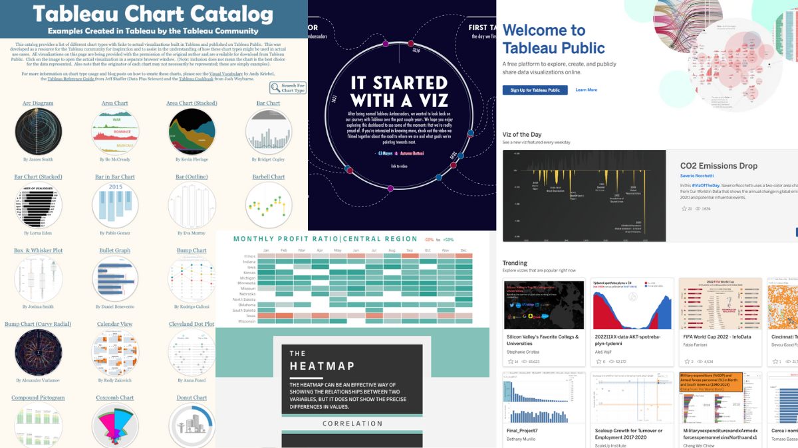
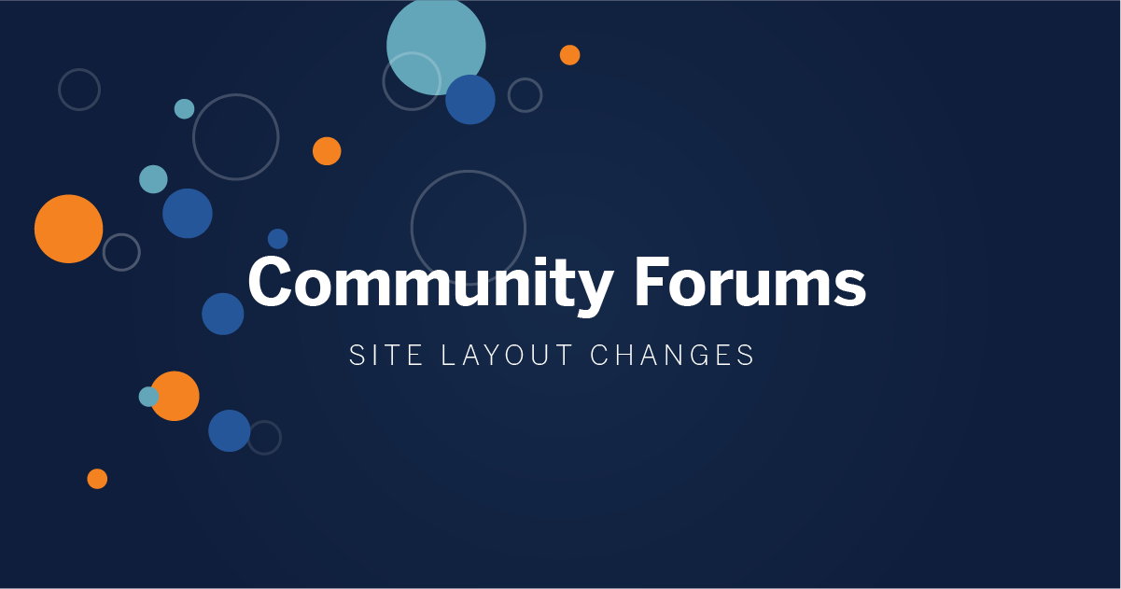
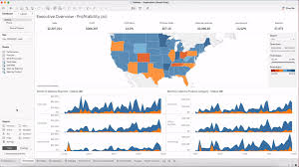
4
You can continue improving through:
- Tableau Public Gallery
Explore dashboards created by other users. Reverse engineer their techniques.
- Tableau Community Forums
Ask questions and learn best practices from experienced users.
- Tableau Blueprint
Enterprise framework for scaling analytics culture and governance.
- Tableau Extensions and Accelerators
Pre-built dashboards and plugins that save time for real business problems.
- Official Certification Paths
  - Tableau Specialist
  - Tableau Data Analyst
  - Tableau Desktop Certified Professional

